DR. SAMBHU CHAKRABORTY
www.sambhuchakraborty.com | info@sambhuchakraborty.com

DATE OF BIRTH: 12TH AUGUST 1968
Residence: 4/2K/34 Ho- Chi- Minh Sarani, Kolkata-7000061, India
Office: 63/21 Nabalia Para Road, Kolkata- 700008, India
E-mail: iol.response@gmail,com, director.iaqm@gmail.com | director@iaqmconsultants.com
Contact: +919830051583/+919748838269
Residence: +9133 24524738 Office: +9133-24944276/24944365

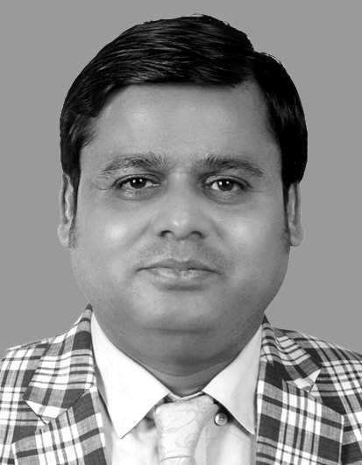



sambhu.chakraborty1

in.linkedin.com/in/s-chakraborty-a38b985b


facebook.com/sambhu.chakraborty.35

EDUCATION QUALIFICATION
MBA, Ph.D in Quality Management. (Thesis title was effective quality assurance and its impact in Medical laboratory)

WORK EXPEREINCE IN QUALITY MANAGEMENT: 22 YEARS
PRESENT POSITION
Director at IAQM Consultants Pvt Ltd and Institute of Applied Quality Management, Kolkata, India. This is the largest laboratory quality accreditation consultants in India
Official website; www.quality-pathshala.com and www.iaqmconsultants.com
HONY. POSITION
Chairman, International Organization for Laboratories (IOL)-a stakeholder organization of ILAC
ACHIEVEMENT AND RECOGNITION
Selected by Indian Council of Medical Research (ICMR) in their Good Clinical Laboratory Practice (GCLP) Advisory and drafting committee. GCLP is the national standard in India for Good Clinical laboratory practice. One of the issuing authority of the standard.

KNOLEDGE AND EXPRIENCE

22 Years in Quality management, started consultancy work on ISO 9000 series of quality standard, gradually started work on ISO Guide 25, ISO/IEC 17025 and ISO 15189 laboratory quality management and accreditation training consultancy for laboratories.

Well conversant with laboratory Quality management system for Industrial testing and calibration laboratories almost from all field and standard requirement of ISO/IEC 17025
Well conversant with Inspection Quality management standard on ISO 17020

Well conversant with Medical laboratory Quality Management and its standard on ISO 15189, conversant with laboratory accreditation specific accreditation criteria of different Accreditation body across the globe

Well conversant and thorough knowledge of all kind of laboratory accreditation standards like CAP and JCI standard, well conversant with other accreditation standard like JCI, AABB and Hospital accreditation standards. Well conversant with ISO 17020 quality management standard for inspection bodies. Rendered Quality Management consultancy services to more than 300 organizations and trained more than 2000 quality professionals.

Well conversant with Hospital Accreditation standard like NABH , JCI and other international hospital quality stndard

- Leading as Business and organization head for Quality Management Training and consultancy for both the organizations- Institute of Applied Quality Management and IAQM consultants Pvt Ltd.

- Heading and leading as Chairman for International Organization for Laboratories (IOL)

- All marketing, communication and promotional activities are supervised personally.

- Quality certification and accreditation concept is promoted by me in Eastern part of India and where I worked as pioneer/ lead person to establish quality management concept in the eastern part of India.

- I started journey with ISO 9000 quality series of standard then gradually ISO/ Guide 25 and ISO /IEC 17025 and lastly ISO 15189

- Laboratory accreditation concept promoted in eastern part of India under my strong leadership, especially Medical laboratory accreditation concept promoted by me under the platform of Institute of Applied quality Management(IAQM). IAQM had given a dedicated effort under my leadership jointly with National Accreditation Board for Testing and Calibration Laboratories (NABL) in the year of 2000. It was the first successful Medical laboratory accreditation workshop and programme and journey of medical laboratory accreditation in the eastern part of India

- Conducted at least 30 promotional workshop in the various part of the country to promote laboratory accreditation

- Bangladesh Accreditation Board also invited me to promote joint workshop in Bangladesh for promotion of medical laboratory accreditation in Bangladesh. First medical laboratory accreditation as per ISO 15189 conducted by me in Bangladesh

- Hospital Accreditation concept by NABH is also promoted by me, first Hospital and first radiology establishment got NABH accreditation through my training and consultancy support.

- Thoroughly conversant with Blood Bank and Cord Blood Bank quality system standard like CAP and AABB standard requriement

RECENT PUBLICATION RELATED TO LABORATORY QUALITY ASSURANCE

- Effectiveness of ISO 15189 :2012 a requirement for medical laboratories with particular reference to organization and management responsibility (clause 4.10 in medical laboratory quality assurance, published in IOSR journal of Business Management, Vol 17, Issue 11. 2015
- Document Control Effectiveness in ISO 15189 Accredited Laboratories International Journal of Business and Management Invention ISSN (Online): 2319 – 8028, ISSN (Print): 2319 – 801X|| Volume 5 Issue 1 || January. 2016 || PP-12-23

